## COLLEGE REPORT HANDLING SYSTEM

**18CS3210R – ENTERPRISE PROGRAMMING PROJECT BASED REPORT**

**ON**

COLLEGE REPORT HANDLING SYSTEM

***submitted in partial fulfillment of the requirement for the award of the degree of***

## BACHELOR OF TECHNOLOGY

**In**

**COMPUTER SCIENCE AND ENGINEERING**

**By**

**Name Idnumber**

**B.Purvaja Durga 180030593**

**P.Sai Sravanthi 180030595**

*Under the Esteemed Guidance of*

# Mr. K.Yellaswamy

***Assistant Professor***



## DEPARTMENT OF COMPUTER SCIENCE AND ENGINEERING

**K L (Deemed to be) University**

Green Fields, Vaddeswaram, Guntur District – 522 502

## (2019-2020)

**DEPARTMENT OF CSE, KLEF**

1

## COLLEGE REPORT HANDLING SYSTEM

**K L (Deemed to be) University**

**DEPARTMENT OF COMPUTER SCIENCE AND ENGINEERING**



**CERTIFICATE**

This is certify that the project based report entitled **“**COLLEGE REPORT HANDLING SYSTEM**”** is a bonafide work done and submitted by B.Purvaja Durga-180030593,P.Sai Sravanthi-180030595 **,**in partial fulfillment of the requirements for the award of the degree of **BACHELOR OF TECHNOLOGY** in Department of Computer Science Engineering, K L (Deemed to be University), Guntur District during the academic year **2019-2020**.

**Mr.K.Yellaswamy Mr. V. HARI KIRAN**

**FACULTYINCHARGE HEAD OF THEDEPARTMENT**

DEPARTMENTOFCSE DEPARTMENT OFCSE

K L (Deemed tobeUniversity) K L (Deemed to beUniversity)

## EXTERNAL EXAMINER

**DEPARTMENT OF CSE, KLEF**

2

## COLLEGE REPORT HANDLING SYSTEM

**K L (Deemed to be) University**

**DEPARTMENT OF COMPUTER SCIENCE AND ENGINEERING**



**DECLARATION**

This is certify that the project based report entitled **“**COLLEGE REPORT HANDLING SYSTEM**”** is a bonafide work done and submitted B.Purvaja Durga-180030593,P.Sai Sravanthi-180030595**,**in partial fulfillment of the requirements for the award of the degree of **BACHELOR OF TECHNOLOGY** in Department of Computer Science Engineering, K L (Deemed to be University), Guntur District during the academic year **2019-2020**.

**B.Purvaja Durga-180030593**

**P.Sai Sravanthi-180030595**

**DEPARTMENT OF CSE, KLEF**

3

## COLLEGE REPORT HANDLING SYSTEM

**ACKNOWLEDGEMENT**

The success in this project would not have been possible but for the timely help and guidance rendered by many people. Our sincere thanks to all those who has assisted us in one way or the other for the completion of myproject.

Our greatest appreciation to our guide **Mr.K.Yellaswamy**, Assistant Professor, Department of Computer Science and Engineering which cannot be expressed in words for his tremendous support, encouragement and guidance for this project.

We express our gratitude to **Mr. V. HariKiran,** Head of the Department for Computer Science and Engineering for providing us with adequate facilities, ways and means by which we are able to complete thisproject.

We thank all the members of teaching and non-teaching staff members, and also who have assisted me directly or indirectly for successful completion of this project.

Finally, We sincerely thank our friends and classmates for their kind help and co- operation during our work.

**B.Purvaja Durga-180030593**

**P.Sai Sravanthi-180030595**

**DEPARTMENT OF CSE, KLEF**

4

## COLLEGE REPORT HANDLING SYSTEM

**CONTENTS**

|  |  |  |
| --- | --- | --- |
| **Chapter No:** | **Tittle** | **Page No** |
| 1 | ABSTRACT | 6 |
| 2 | METHODOLOGY (Modules  Description) | 7 |
| 3 | BLOCK DIAGRAM | 8 |
| 4 | SOFTWARE  REQUIREMENTS | 9-11 |
| 5 | IMPLEMENTATION  (Source Code) | 12-15 |
| 6 | OUTPUT SCREENSHOTS | 16-19 |
| 7 | SCOPE OF PROJECT | 20 |
| 8 | CONCLUSION AND  FUTURE SCOPE | 21 |

**DEPARTMENT OF CSE, KLEF**

5

## COLLEGE REPORT HANDLING SYSTEM

1. **ABSTRACT**

The objective of COLLEGE REPORT HANDLING SYSTEM is to allow the administrator of any organization to edit and find out the personal details of a student and allows the student to keep upto the date his profile and all the information about a student will be available in few seconds .overall ,it’ll make student information an easier job for the administrator and the student of any organization .The main purpose of this project is to illustrate the requirements of the project college report handling system and is intended to help any organization to maintain and manage personal data

.

**DEPARTMENT OF CSE, KLEF**

6

## COLLEGE REPORT HANDLING SYSTEM

**2.Methodology**

## Once an end user opens the college report handling system’s home page there will be 3 options to click on-

**1.** ADMIN

2. FACULTY

3. STUDENTS

1. ADMIN:

Responsible for managing user records.

1.login into the website

2.update the information

3.accept/decline user request

4.view user details

2. FACULTY:

Rights to view and edit their personal details

1.login into the website

2.view their details

3.edit their details

4.view schedule information

3.STUDENTS :

Rights to view and edit their personal details

1.login into the website

2.edit their details

3.view their details

4.view course details

**DEPARTMENT OF CSE, KLEF**

7

## COLLEGE REPORT HANDLING SYSTEM

1. **BLOCKDIAGRAM**

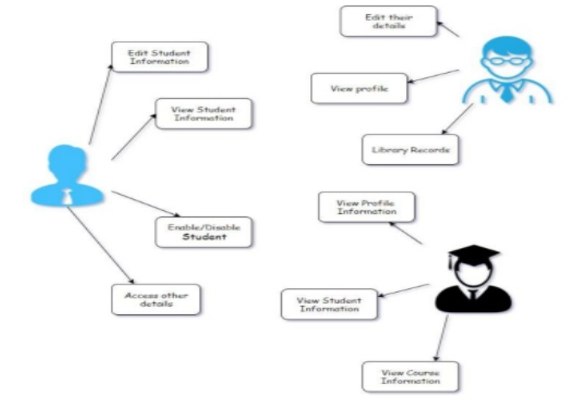

**DEPARTMENT OF CSE, KLEF**

8

## COLLEGE REPORT HANDLING SYSTEM

**4.SOFTWAREREQUIREMENTS**

**Front End– HTML, CSS and Javascript**

**HTML:** In this project HTML was used in the front end to create web pages. HTML was used. Through HTML the following pages were created:

Home page- which displayed all the options that the end user can click on.

Employee page- Which in turn had employee login page and employee register page which were created with HTML.

Manager page- which had the manager login page, manager home page, manager view permissions page in HTML.

Leader page- Which had the leader login page, leader home page, leader view permissions page. The attributes used are <html>, <head>, <body>, <br>, etc.

**CSS:**CSS. Stands for "Cascading Style Sheet." Cascading style sheets are used to format the layout of Web pages.

In this project, we use CSS to create header and footer dvisions. Div is used to create and style the header and footer of each page.

The background image was also assigned with CSS using URL. For ex:

background-image: url("https://i1.wp.com/firstcovgr.org/wp-content/uploads/2016/03/Open- Book-on-wood-table.jpg");

**Javascript:** In this project javascript is used for redirecting pages to another page and getting the values entered by the user.

JavaScript is a programming language used primarily by Web browsers to create a dynamic and interactive experience for the user.

Most of the functions and applications that make the Internet indispensable to modern life are coded in some form of JavaScript.

**DEPARTMENT OF CSE, KLEF**

9

## COLLEGE REPORT HANDLING SYSTEM

**Middleware – JSP**

**JSP:** In this project, JSP was used to create login, register pages and so on. It is mainly used to get establish a connection with the database and store the necessary. JSP is a file extension for Java Server Pages file format. A JSP is an HTML page containing a reference to Java servlets, or, java server side applets. JSP files help to deliver server side customized content on a webpage through servlets.

A JavaServer Pages component is a type of Java servlet that is designed to fulfill the role of a user interface for a Java web application. Web developers write JSPs as text files that combine HTML or XHTML code, XML elements, and embedded JSP actions and commands.

## Backend – Oracle

**Oracle:**A database server also prevents unauthorized access and provides efficient solutions for failure recovery. Oracle Database is the first database designed for enterprise grid computing, the most flexible and cost effective way to manage information and applications. Oracle database is a collection of physical operating system files or disks (in the simplest terms). Oracle instance is set of Oracle background processes or threads and a shared memory area, which is memory that is shared across those threads or processes running on a single computer.

## IDE – Eclipse

**Eclipse:**The entire project was done using Eclipse IDE which was useful for html pages, jsp pages. In the context of computing, Eclipse is an integrated development environment (IDE) for developing applications using the Java programming language and other programming languages such as C/C++,Pythonetc. Eclipse can be used as an IDE for anyprogramming

language for which a plug-in is available.

**DEPARTMENT OF CSE, KLEF**

10

## COLLEGE REPORT HANDLING SYSTEM

**Web server – Apache Tomcat 7**

**Apache Tomcat 7:** The Apache Tomcatsoftware is an open source implementation of the Java Servlet,JavaServerPages.Apache Tomcat is used to deploy your Java Servlets and JSPs. So in your Java project you can build your WAR file, and just drop it in the deploy directory in Tomcat. So basically Apache is an HTTP Server, serving HTTP. Tomcat is a Servlet and JSP Server serving Java technologies.

## Development Kit – JDK 1.7

**JDK 1.7:** The Java Development Kit (JDK) is a software development environment used for developing Java applications and applets. It includes the Java Runtime Environment (JRE), an interpreter/loader (java), a compiler (javac), an archiver (jar), a documentation generator (javadoc) and other tools needed in Java development.

**DEPARTMENT OF CSE, KLEF**

11

## COLLEGE REPORT HANDLING SYSTEM

5. **IMPLEMENTATION**

index.html:

-----------

<!DOCTYPE HTML PUBLIC "-//W3C//DTD HTML 4.0 Transitional//EN">

<HTML>

<HEAD>

<TITLE> New Document </TITLE>

<META NAME="Generator" CONTENT="EditPlus">

<META NAME="Author" CONTENT="">

<META NAME="Keywords" CONTENT="">

<META NAME="Description" CONTENT="">

</HEAD>

<frameset rows="20%,*,10%" border="5px">

<frameset cols="15%,*" border="0px">

<frame src="logo.html" name="logo" scrolling="no"/>

<frame src="heading.html" scrolling="no"/>

</frameset>

<frameset cols="15%,*,20%" border="1px">

<frame src="list.html" noresize="noresize" scrolling="yes"/>

<frame src="intro.html" noresize="noresize" scrolling="yes"/>

<frame src="details.html" noresize="noresize" scrolling="no"/>

</frameset>

<frameset cols="*" border="1px">

<frame src="footer.html" scrolling="no">

</frameset>

</frameset>

<BODY bgcolor="#990000" >

<img src="1.png" height="100" width="300"></img>

**DEPARTMENT OF CSE, KLEF**

12

## COLLEGE REPORT HANDLING SYSTEM

<font size="4" color="#990000" face="verdana">

<p>

KL (Deemed to be University) placed #71-75 Rank in QS India University Rankings 2019

KL Ranked #1 among Young Universities by Outlook-ICARE India University Rankings 2019.

KLEF Ranked 12th in Top 140 Engineering Institutes in India by Times Engineering Survey 2019.

"Indian Education Network has awarded K L as "Best Higher Education Institute for Skill Development "at 6th Skill Development Summit 2018.

OUTLOOK & Drshti Engineering College Survey 2018 has awarded K L College of Engineering as No.1 Private Engineering College in Andhra Pradesh State.

Higher Education Review Survey 2018 has awarded K L as No.1 Deemed University in Andhra Pradesh State.

K L Campus got 1St Rank under Universities (Private) Category at AP Green Awards announced by Govt. of Andhra Pradesh.

India Today Magazine Survey 2018 has ranked K L as 9th Best Private University in India.

</p>

## style="background-color:#990000">

## <div style="position:absolute;left:400px;top:100px;">

## <form action="insertion.jsp" method="post">

## <caption><h2 align="center" style='color:white;font-size:40px;font-style:italic;font-weight:bold'>Enter Details</h2></caption>

## <table>

## <tr>

## <td><b><p align="center" style='color:white;font-size:20px;font-style:italic;font-weight:bold'>Enter Name :</p></b></td>

## <td >

## <input type="text" name="name" required></td>

## </tr>

## <tr>

**DEPARTMENT OF CSE, KLEF**

13

## COLLEGE REPORT HANDLING SYSTEM

## <td><b><p align="center" style='color:white;font-size:20px;font-style:italic;font-weight:bold'>Enter ID :</p></b></td>

## <td><input type="text" name="id" required></td>

## </tr>

## <tr>

## <td><b><p align="center" style='color:white;font-size:20px;font-style:italic;font-weight:bold'>Enter PhoneNumber :</p></b></td>

## <td><input type="text" name="phonenumber" required></td>

## </tr>

## 

## <tr>

## <td><b><p align="center" style='color:white;font-size:20px;font-style:italic;font-weight:bold'>Enter Email Address:</p></b></td>

## <td><input type="text" name="email" required></td>

## </tr>

## <tr>

## <td><b><p align="center" style='color:white;font-size:20px;font-style:italic;font-weight:bold'>Enter Address:</p></b></td>

## <td><input type="text" name="address" required></td>

## </tr>

## <tr>

## <td>

## <p align="center"><input type="submit" value="submit"/></p></td>

## </tr>

## </form>

## </div>

## </table>

## </p>

## </body>

## </html>

**DEPARTMENT OF CSE, KLEF**

14

## COLLEGE REPORT HANDLING SYSTEM

Data Flow diagram

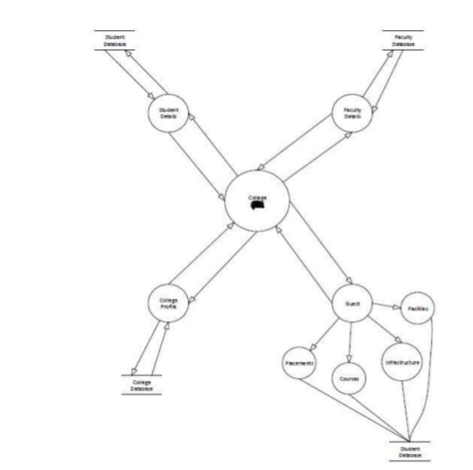

**DEPARTMENT OF CSE, KLEF**

15

## COLLEGE REPORT HANDLING SYSTEM

1. **OUTPUT SCREENSHOTS**

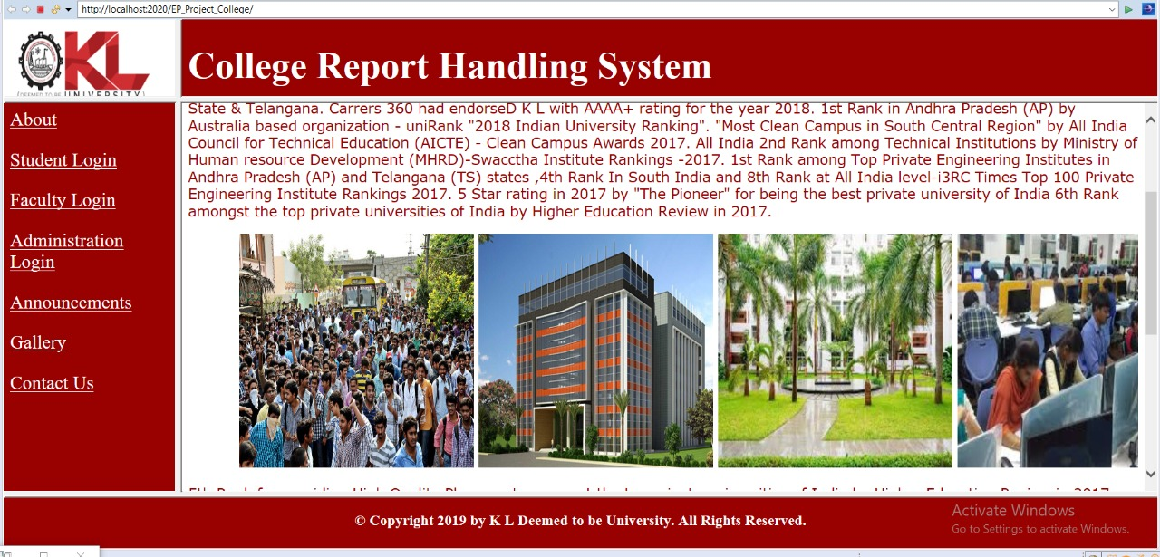

## C:\Users\sravanthi\Desktop\login.jpeg

**DEPARTMENT OF CSE, KLEF**

16

## 

## COLLEGE REPORT HANDLING SYSTEM

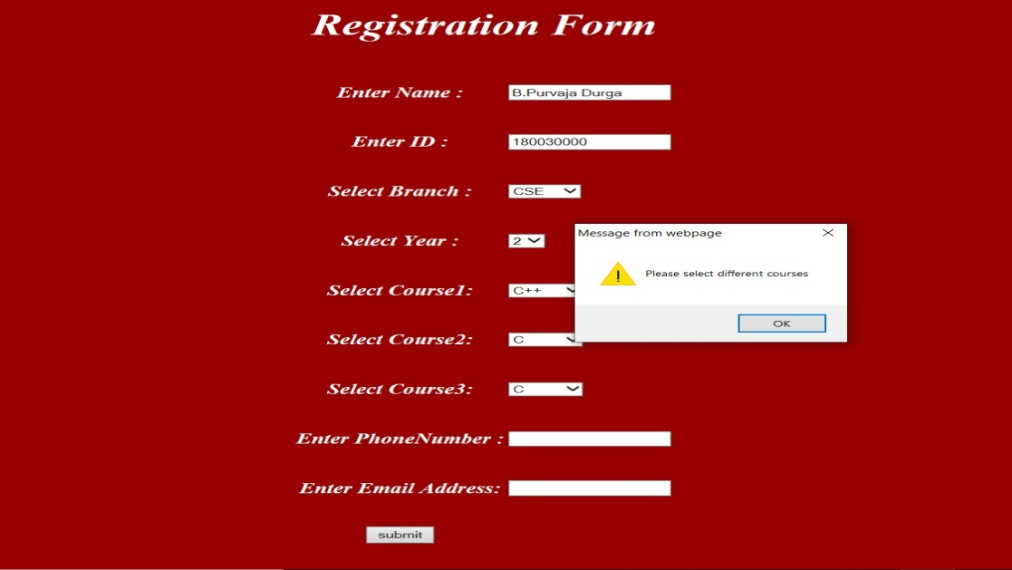

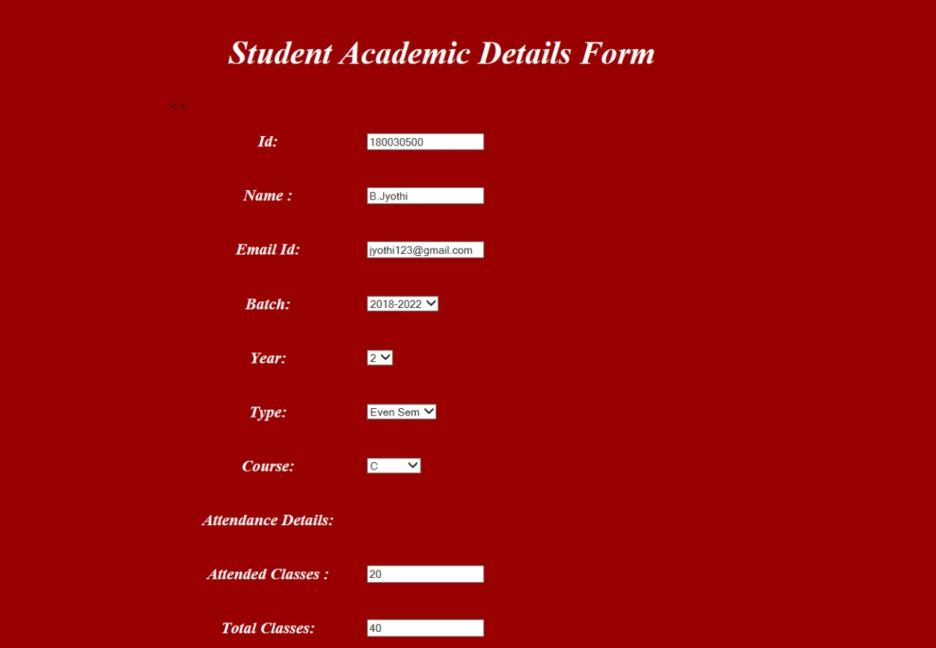

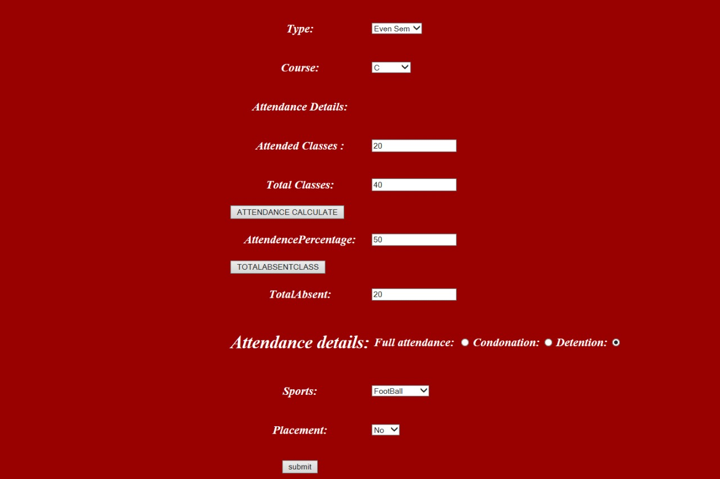





**DEPARTMENT OF CSE, KLEF**

17

## COLLEGE REPORT HANDLING SYSTEM

## C:\Users\sravanthi\Desktop\WhatsApp Image 2020-06-08 at 12.18.23 PM.jpeg

## C:\Users\sravanthi\Desktop\WhatsApp Image 2020-06-08 at 12.18.24 PM.jpeg

## C:\Users\sravanthi\Desktop\WhatsApp Image 2020-06-08 at 12.18.24 PM (1).jpeg

**DEPARTMENT OF CSE, KLEF**

18

## COLLEGE REPORT HANDLING SYSTEM

## 

## C:\Users\sravanthi\Desktop\WhatsApp Image 2020-06-08 at 12.18.25 PM.jpeg

## 

## 

**DEPARTMENT OF CSE, KLEF**

19

## COLLEGE REPORT HANDLING SYSTEM %>

Scope of the project:

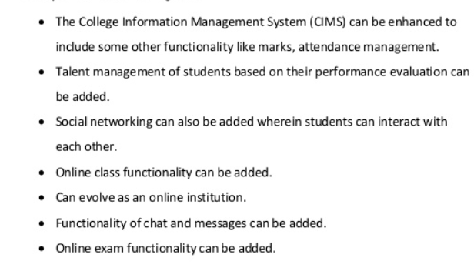

**DEPARTMENT OF CSE, KLEF**

20

## COLLEGE REPORT HANDLING SYSTEM

Conclusion:

This thesis has attempted the improvement of the teaching-learning process in higher educational institutions by using knowledge management. The unique feature in this project is that it covers almost every part of an educational organization which is very important to improve the quality of education. In this work almost all the methods have been used to extract the knowledge from the contributors, who are related to the educational organizations. Implicit knowledge is the backbone of the knowledge portal; so, this knowledge has been managed very well in this portal .A knowledge society is achievable

once the Knowledge portal and knowledge management systems are

implemented in all the higher educational institutions.

**DEPARTMENT OF CSE, KLEF**

21